

AMRITA SCHOOL OF ENGINEERING, BANGALORE
AMRITA VISHWA VIDYAPEETHAM
BANGALORE 560 035

PHONE BOOK DIRECTORY

A PROJECT REPORT

Submitted by

BL.EN.U4AIE21015 - B. Sai Abhishek
BL.EN.U4AIE21017 - B. Ruchith Balaji
BL.EN.U4AIE21038 - Chillakuru Hari

For the subject

21AIE111- Data Structures and Algorithms -1

Faculty Incharge
Mr. C. Ullas

CONTENTS

S. No | Topic | Pg. No
1 | Abstract | 3
2 | Literature Survey | 4
3 | Data Structure Explanation | 5
4 | Detailed Description | 9
5 | Code | 12
6 | Output Screenshots | 19

ABSTRACT

The phonebook directory works specifically for tracking people. The Phonebook directory contains a set of basic functions for adding, and deleting new contacts. This phonebook directory allows you to perform simple tasks in your phonebook, such as mobile phones. You can add text to the phonebook, find, search, and delete. The concept of file management and data structure is often used in almost all functions in this project. It uses functions, file management, and data structure.

This directory provides information on adding and deleting data from/to files. Adding new entries, browsing them, searching for saved contacts, and deleting contacts in the phonebook is one of the most important services that become the main menu in the phonebook directory.

When you add anything to your phone book, you will be asked for personal information such as name, first name, phone number, nationality, email address, and address. You can then view, search, and delete this text.

LITERATURE SURVEY

In this Work the phone directory will store the first name, last name and the phone number. When inserting, we’re going to want to insert the new record into the correct order without creating or using a sorting algorithm.
You may have duplicate names but not duplicate phone numbers. The phone directory should be sorted by last name, first name, phone number. When deleting a record, there will not be a current record that’s selected. To select the record after deletion, you must use the select the current record option. You will not be able to change the first name, last name or phone number unless the current record is selected.

But Our team has modified the program using linked list and it became very easy to search the phone number by email and search the phone number by name and add a phone number with in 2 steps and each phone number has its own index number so that if similar names are there we can’t confuse

LINKED LIST

Linked List can be defined as collection of objects called nodes that are randomly stored in the memory.
A node contains two fields i.e. data stored at that particular address and the pointer which contains the address of the next node in the memory.
The last node of the list contains pointer to the null.

Linked List Representation

- Linked List contains a link element called first.
- Each link carries a data field(s) and a link field called next.
- Each link is linked with its next link using its next link.
- Last link carries a link as null to mark the end of the list.

Types of Linked List
Following are the various types of linked list.
- Simple Linked List − Item navigation is forward only.
- Doubly Linked List − Items can be navigated forward and backward.
- Circular Linked List − Last item contains link of the first element as next and the first element has a link to the last element as previous.

Uses of Linked List
- The list is not required to be contiguously present in the memory. The node can reside anywhere in the memory and linked together to make a list. This achieves optimized utilization of space.
- list size is limited to the memory size and doesn't need to be declared in advance.
- Empty node cannot be present in the linked list.
- We can store values of primitive types or objects in the singly linked list.

Basic Operations
Following are the basic operations supported by a list.
- Insertion − Adds an element at the beginning of the
list.

- Deletion − Deletes an element at the beginning of the
list.

- Display − Displays the complete list.

- Search − Searches an element using the given key.

- Delete − Deletes an element using the given key.

Singly linked list
Singly linked list can be defined as the collection of ordered set of elements. The number of elements may vary according to need of the program. A node in the singly linked list consist of two parts: data part and link part. Data part of the node stores actual information that is to be represented by the node while the link part of the node stores the address of its immediate successor.
One way chain or singly linked list can be traversed only in one direction. In other words, we can say that each node contains only next pointer, therefore we cannot traverse the list in the reverse direction.
Advantages and Disadvantages of Singly Linked List:
Advantages:
- It is very easier for the accessibility of a node in the forward direction.
- The insertion and deletion of a node are very easy.
- The Requirement will less memory when compared to doubly, circular or doubly circular linked list.

Disadvantages:
- Therefore, Accessing the preceding node of a current node is not possible as there is no backward traversal.
- The Accessing of a node is very time-consuming.

DETAILED DESCRIPTION

The Phone book directory project is done by using Singly Linked List. It contains Variables Name, Email, Phone numbers. With these Variables methods are created. The methods are:

  - Creating a Database to store Contacts
  - Adding Contacts
  - Restoring Data from Database
  - Deleting Contacts
  - Find Phone number with E-mail
  - Find Phone number with Name
  - Displaying all the Contacts
  - Quit.

Creating a Database to store Contacts:

All the Contacts that are created are stored in to File which is in the Data Base. It contains all the data (Name, E-mail, Phone number)

Adding Contacts:

After implementing the code, It asks for select a Option to proceed. If we select Add Contact option it asks for Name, Email, and Phone Number and creates the Contact with Contact Number

Restoring Data from Database

We can Restore the contacts that we have created previously are stored in Database file. By Choosing the option we can restore the data

Deleting Contacts:

After implementing the code, It asks for select a Option to proceed. If we select Delete Contact option it asks for Contact number. If the Phone book is empty, it shows the BOOK IS EMPTY. If not, it Deletes the Contact with number that we give.

Find Phone number with E-mail:

After implementing the code, It asks for select a Option to proceed. If we select Email search option it asks for E-mail to enter and then it shows the Phone number corresponding to that Email.

Find Phone number with Name:

After implementing the code, It asks for select a Option to proceed. If we select Search Contact option it asks for Name to enter and then it shows the Phone number corresponding to that Name.

Displaying all the Contacts:

If we want to see the contacts in the Phone Book, By Clicking the corresponding key in the Menu, It displays all the contacts in the Phone book.

Quit:

By choosing the option Quit, the program will be quitted.

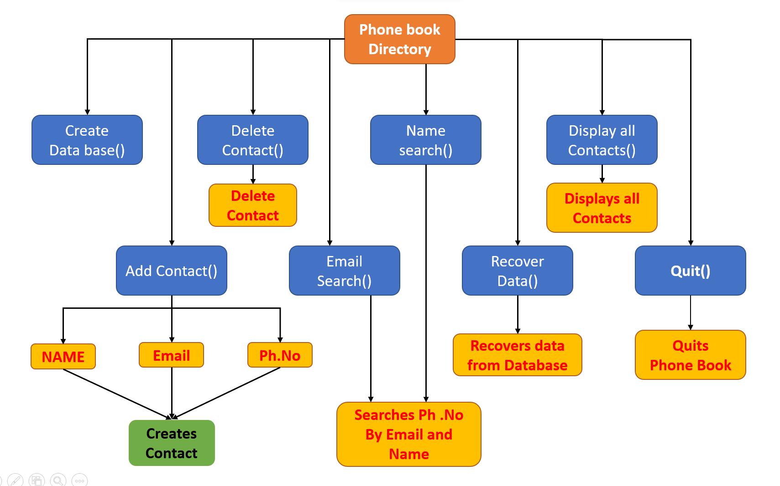
Block Diagram

CODE
Phonebook.java
package Phonebook;
import java.util.*;
public class PhoneBook {

public static void main(String[] args) {

SLList newList = new SLList();
InputOutput newIO = new InputOutput();
Scanner in = new Scanner(System.in);
String fileName = "";

String menu;
boolean done = false;

do {
System.out.println();
System.out.format(" SELECT THE OPTION YOU WANT TO PROCEED%n");
System.out.format("---------------------------------------%n");
System.out.format("(A)-add a contact \n(D)-delete a contact \n(E)-Email Search \n(P)-Print all the contacts \n(R)-Restore from database \n(S)-Search contacts \n(W)-Write to Disk \n(Q)-Quit%n");
System.out.format("----------------------------------------%n");
System.out.format("Please Enter a command: ");
menu = in.nextLine().toUpperCase();

switch (menu) {
case "A":
System.out.println("Follow the Procedure");

System.out.print("Step1 : Enter a FIRST and LAST Name: ");
String name = in.nextLine();

System.out.print("Step2 : Enter an EMAIL ADDRESS: ");
String email = in.nextLine();

System.out.print("Step3 : Enter a PHONE NUMBER: ");
String phoneNumber = in.nextLine();

newList.add(name, email, phoneNumber);
System.out.print("Your required contact has been created!");
System.out.println();
break;
case "D":
System.out.print("Enter contact number to delete: ");
int delete = in.nextInt();

System.out.println("Restore from disk");
if(fileName.equals("")){
fileName = "pages";
}
newIO.readFile(fileName);
break;
case "S":
System.out.print("Enter a Name to search for contact: ");
String sName = in.nextLine();
newList.nameSearch(sName);
break;
case "W":
System.out.println("Write to disk\n");
if(fileName.equals("")){
System.out.print("Name of file: ");
fileName = in.nextLine();
}else{
System.out.print("Use existing file " + fileName + " ? (Y/N): ");
String yn = in.nextLine();
switch(yn.toLowerCase()){
case "y":
break;
case "n":
System.out.print("New file name: ");
fileName = in.nextLine();
}
}
newIO.writeFile(fileName, newList);
break;
case "Q":
System.out.println("Exiting!");
done = true;
break;
default:
System.out.println("Unknown entry");
}
} while (!done);
System.out.println("Thanks for using phone book Directory");
}
}

newList.delete(delete);
break;
case "E":
System.out.print("Enter an E-mail to search for: ");
String sEmail = in.nextLine();
newList.emailSearch(sEmail);
break;
case "P":
System.out.println("Print Phonebook");
newList.printList();
break;
case "R":
System.out.println("Restore from disk");
if(fileName.equals("")){
fileName = "pages";
}
newIO.readFile(fileName);
break;
case "S":
System.out.print("Enter a Name to search for contact: ");
String sName = in.nextLine();
newList.nameSearch(sName);
break;
case "W":
System.out.println("Write to disk\n");
if(fileName.equals("")){
System.out.print("Name of file: ");
fileName = in.nextLine();
}else{
System.out.print("Use existing file " + fileName + " ? (Y/N): ");
String yn = in.nextLine();
switch(yn.toLowerCase()){
case "y":
break;
case "n":
System.out.print("New file name: ");
fileName = in.nextLine();
}
}
newIO.writeFile(fileName, newList);
break;
case "Q":
System.out.println("Exiting!");
done = true;
break;
default:
System.out.println("Unknown entry");
}
} while (!done);
System.out.println("Thanks for using phone book Directory");
}
}

SLLIST.java
package Phonebook;
import java.io.Serializable;
public class SLList implements Serializable {
private SLNode head;
private int length;
public SLList() {
head = null;
length = 0;
}
public void add(String name, String email, String phoneNumber) {
SLNode current = head;
SLNode previous = null;
SLNode newNode = new SLNode();
newNode.setName(name);
newNode.setEmail(email);
newNode.setPhoneNumber(phoneNumber);
if (isEmpty()) {
head = newNode;
length++;
} else {
for (int i = 0; i < length; i++) {
String[] ourNames1 = current.getName().split(" ");
String[] ourNames2 = newNode.getName().split(" ");
int result = ourNames1[ourNames1.length-1].compareToIgnoreCase(ourNames2[ourNames2.length-1]);
if (result > 0) {
if (previous == null) {
newNode.setNext(current);
head = newNode;
length++;
break;
}
previous.setNext(newNode);
newNode.setNext(current);
length++;
break;
}
else
{
if (current.getNext() == null) {
current.setNext(newNode);
newNode.setNext(null);
length++;
break;
}
System.out.println("Add after");
previous = current;
current = current.getNext();
}
}

}
current = current.getNext();
}
if (empty){
System.out.println("No matches to that name!");
}
}
}
public void emailSearch(String email) {
SLNode current = head;
boolean empty = true;
if (isEmpty()) {
System.out.println("No Contacts Available in Phone book!");
}else {
for (int i = 0; i < length; i++) {
if (current.getEmail().toLowerCase().contains(email.toLowerCase())) {
System.out.print("Index = " + (i+1) + " ");
System.out.println(current);
empty = false;
}
current = current.getNext();
}
if (empty){
System.out.println("No matches to that email address!");
}
}
}
public void delete (int index) {
SLNode current = head;
SLNode previous = null;
boolean empty = true;
if (isEmpty()) {
System.out.println("The phone book is empty!");
} else {
for (int i = 0; i < length; i++) {
if ((index-1) == i) {
if (previous == null) {
head = head.getNext();
length--;
empty = false;
break;
} else if (current.getNext() == null){
previous.setNext(null);
length--;
empty = false;
break;
} else {
previous.setNext(current.getNext());
length--;
empty = false;
break;
}
} else {
previous = current;
current = current.getNext();
}
}
if (empty){
System.out.println("Contact NO Does Not Exist!");
} else {
System.out.println("Successfully deleted contact NO " + index);
}
}
}
}

}
}
public void printList () {
SLNode tempNode = head;
if (head == null) {
System.out.println("NO CONTACTS AVAILABLE");
} else {
for (int i = 0; i < length; i++) {
System.out.print("CONTACT NO : " + (i+1) + " ");
System.out.println(tempNode);
tempNode = tempNode.getNext();
}
}
System.out.println();
}
public boolean isEmpty() {
return (length == 0);
}
public void nameSearch(String name) {
SLNode current = head;
boolean empty = true;
if (isEmpty()) {
System.out.println("No Contacts Available in Phone book!");
}else {
for (int i = 0; i < length; i++) {
if (current.getName().toLowerCase().contains(name.toLowerCase())) {
System.out.print("Index = " + (i+1) + " ");
System.out.println(current);
empty = false;

}
current = current.getNext();
}
if (empty){
System.out.println("No matches to that name!");
}
}
}
public void emailSearch(String email) {
SLNode current = head;
boolean empty = true;
if (isEmpty()) {
System.out.println("No Contacts Available in Phone book!");
}else {
for (int i = 0; i < length; i++) {
if (current.getEmail().toLowerCase().contains(email.toLowerCase())) {
System.out.print("Index = " + (i+1) + " ");
System.out.println(current);
empty = false;
}
current = current.getNext();
}
if (empty){
System.out.println("No matches to that email address!");
}
}
}
public void delete (int index) {
SLNode current = head;
SLNode previous = null;
boolean empty = true;
if (isEmpty()) {
System.out.println("The phone book is empty!");
} else {
for (int i = 0; i < length; i++) {
if ((index-1) == i) {
if (previous == null) {
head = head.getNext();
length--;
empty = false;
break;
} else if (current.getNext() == null){
previous.setNext(null);
length--;
empty = false;
break;
} else {
previous.setNext(current.getNext());
length--;
empty = false;
break;
}
} else {
previous = current;
current = current.getNext();
}
}
if (empty){
System.out.println("Contact NO Does Not Exist!");
} else {
System.out.println("Successfully deleted contact NO " + index);
}
}
}
}

boolean empty = true;
if (isEmpty()) {
System.out.println("The phone book is empty!");
} else {
for (int i = 0; i < length; i++) {
if ((index-1) == i) {
if (previous == null) {
head = head.getNext();
length--;
empty = false;
break;
} else if (current.getNext() == null){
previous.setNext(null);
length--;
empty = false;
break;
} else {
previous.setNext(current.getNext());
length--;
empty = false;
break;
}
} else {
previous = current;
current = current.getNext();
}
}
if (empty){
System.out.println("Contact NO Does Not Exist!");
} else {
System.out.println("Successfully deleted contact NO " + index);
}
}
}
}

SLNODE.java
public class SLNode implements Serializable {

private String name;
private String email;
private String phoneNumber;
private SLNode next;
public SLNode() {
//data = -1;
next = null;
}
public String getName() {
return name;
}
public void setName(String name) {
this.name = name;
}
public String getEmail() {
return email;
}
public void setEmail(String email) {
this.email = email;
}
public String getPhoneNumber() {
return phoneNumber;
}
public void setPhoneNumber(String phoneNumber) {
this.phoneNumber = phoneNumber;
}
public SLNode getNext() {
return next;
}
public void setNext(SLNode next) {
this.next = next;
}
@Override
public String toString() {
return "Name = " + name + ", Email = " + email + ", Phone Number = "
+ phoneNumber;
}
}

InputOutput.java
package Phonebook;
import java.io.FileInputStream;
import java.io.FileNotFoundException;
import java.io.FileOutputStream;
import java.io.IOException;
import java.io.ObjectInputStream;
import java.io.ObjectOutputStream;
public class InputOutput {
public void writeFile(String file, SLList list) {
ObjectOutputStream o = null;
try {
o = new ObjectOutputStream(new FileOutputStream(file));
} catch (FileNotFoundException e) {
e.printStackTrace();
} catch (IOException e) {
e.printStackTrace();
}
try {
o.writeObject(list);
System.out.println("We have created a File!");
} catch (IOException e) {
e.printStackTrace();
}
try {
o.close();
} catch (IOException e) {
e.printStackTrace();
}
}
public SLList readFile(String file) {
ObjectInputStream i = null;
SLList temp = null;

try {
i = new ObjectInputStream(new FileInputStream(file));
} catch (FileNotFoundException e) {
e.printStackTrace();
} catch (IOException e) {
e.printStackTrace();
}
try {
temp = (SLList) i.readObject();
System.out.println("Successfully restored data from file!");
} catch (ClassNotFoundException e) {
e.printStackTrace();
} catch (IOException e) {
e.printStackTrace();
}
try {
i.close();
} catch (IOException e) {
e.printStackTrace();
}
return temp;
}
}

OUTPUT SCREENSHOTS

- Create a DATA BASE to store the Contacts
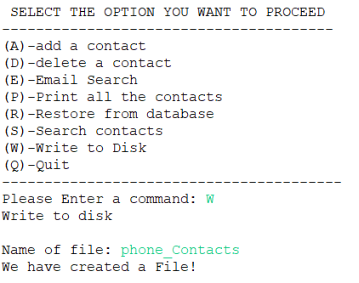

- Adding Contact to the Phonebook
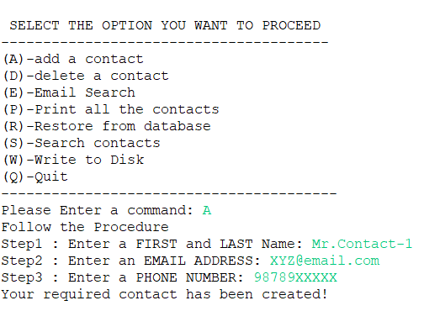

Restore Contacts from the Data Base

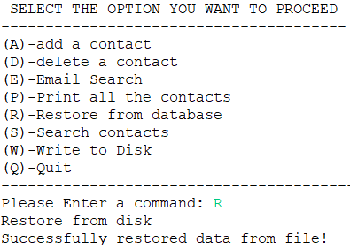

Deleting Contact from the Phonebook
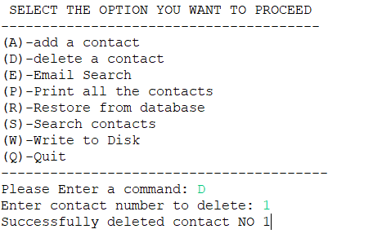

Search Contact in the Phonebook with Email
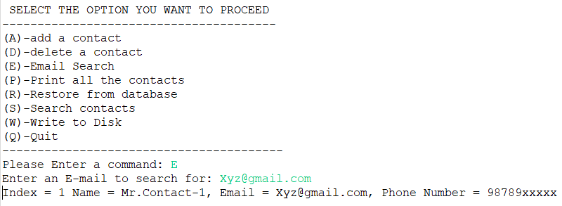

Search Contact in the Phonebook with Name

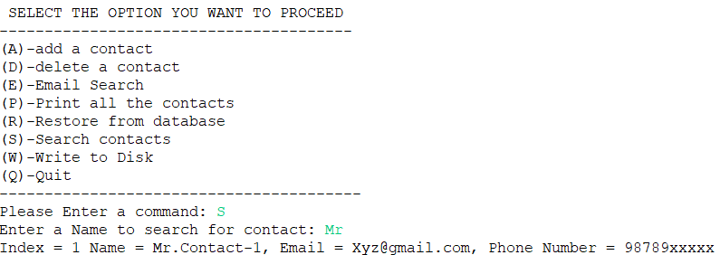

Displaying all the Contacts

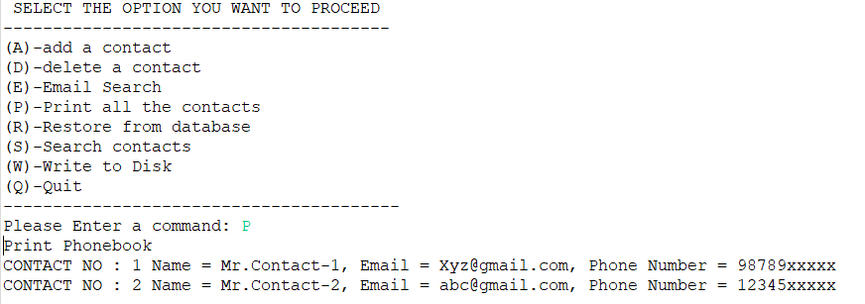

Exiting the Phone Book
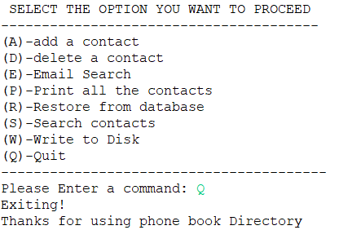

CONCLUSION

  - This Phonebook directory System Project in java with is a project created only for the purpose of meeting educational requirements.
  - Personal information, such as name, phone number, e-mail is requested when you add a record to your phonebook. These records can then be entered, searched, and deleted.

